Final Project Report-ITEC 5010
Applied Programming
By
Josimar Kouam
ID#101251911
Carleton University
Lecturer: Dr. Mehdi Niknam

Outline
- Plan
- Objectives
- Challenges
- Observations
- Conclusion

- Plan
Exploratory data analysis: some visualizations will be conducted to have more insight about out dependents and dependent variable.
Preprocessing:
- Unnecessary features will be remove from the data set.
- The data will be scale if necessary
- Outliers will be remove from the training data
- We will use the Pearson correlation coefficient to evaluate the statistical significance of our features towards our target.
Data set split: We will use two approach to split our data set
- Train_test_split: we will use 70% for training purpose and 30% for testing
- Cross validation: we will use “RepeatedKFold” with ten split repeated three times
Model selection:
- We will build a pipeline containing the following models:
- LinearRegression
- Ridge
- Adaboost Regression
- Support Vector Machine
- Decision Tree
- K-nearest neighbors (KNN)
Create a dictionary containing all those models
A function taking a model as input in returning the score and evaluation metrics (mean absolute error, r2 score, and cross validation score) will be drawn
We will use a “for loop” to run all our models at once and see which one perform the best.
Hyper parameter tuning: we will try to improve the performance of the selected models by finding its best parameters
Evaluate the model: see if there will be an improvement
Prediction: feed the model with new input and see if it correctly predict.
Flask: I will use this framework to deploy the model. They will be two HTML pages. One (index.html) where the features data will be entered and another (abalone-age.html) to display the predicted value.
- Objectives
Our goal is to build a regression machine-learning algorithm that will predict the age of the “abalone”. According to Cambridge dictionary, an abalone is a “small sea creature that can be eaten. It lives inside a shell that is the shape of an ear and is white and shiny inside”. A more common name for abalone is “snail”
The age of an abalone is determine by cutting the shell through the cone, coloring it, and counting the number of rings using a microscope a tedious and lengthy task. Therefore, we will try to automate this process by deploying our model using “flask” framework. By adding 1.5 to the rings feature, we can compute the age of the abalone, in years.
Furthermore, the skill or performance of a regression model must be report as an error in those predictions. This actually makes sense. If we are predicting a numeric value like a height or a dollar amount, we do not want to know if the model predicted the value exactly (which could be intractably difficult in practice); instead, we want to know how close the predictions were to the expected values. That is why our models will evaluated on the basis of errors:
- Mean absolute error (MAE)
- Mean squared error (MSE);
- r2 score.
In addition, I will try to convert the problem to classification problem where there will be two class of age: A and B. B representing age between 2.5-10.5 and B the age between 10.5-30.5. 2.5 is the minimum age value and 30.5 the maximum of our target class.
- Challenges
Though features are not normally distributed, there are close to normality (values between 0 and 1). However there is a use gap between the features and the target features whose values range from two (2) to almost thirty-one (31). For a regression problem, unfortunately this issue affect the performance of a model despite the relatively low, mean Squared Error. Even after scaling the target feature, the results were still the same. However, compare to other available models who address the same problem, my model show a better performance with much lower error and an r2 score close to 52%.
Deploying the model using flask framework required certain subtleties. It took a lot of time and “trial and error” to finally have it work.

- Observations
We see that the distributions of sex between the different age categories have a significant overlap, so sex would not be a good predictor of age. I decided to remove it.
The p-values calculated showed a relatively strong statistical significance between the features and the target. By convention, when the
- p-value is < 0.001: we say there is strong evidence that the correlation is significant.
- p-value is < 0.05: there is moderate evidence that the correlation is significant.
- p-value is < 0.1: there is weak evidence that the correlation is significant.
- p-value is > 0.1: there is no evidence that the correlation is significant.
All the p-value were < 0.01. The ‘Shell weight’ feature had a p-value of zero. This result shows that there is an extremely strong evidence that the correlation is significant as the difference between two attributes is zero.
The regression plot showed a positive direct correlation between all the features with the target.
The features are also highly correlated amongst themselves, which is not go for a regression problem. A forward feature selection was perform and four features were selected but this did not improve the performance of our model
Out of all the six models, linear regression and Ridge regression have the best performance. The best performance is achieve when using cross validation with a mean absolute error of 1.6328 and 1.6377 for the linear and Ridge respectively.
After tuning our Ridge model, we obtained the hyper parameter alpha value= 0.14. With this value we fit our Ridge model again and slightly improve it with a mean square error now 1.63245
The chosen model was fit with an input and correctly provided with a relatively acceptable result.

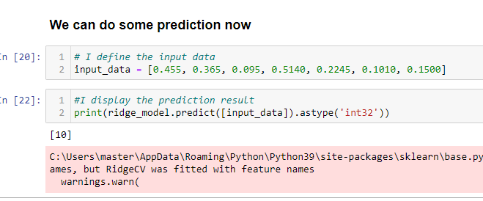
Out of the three models used for the classification Random forest came first with an accuracy of 76%.
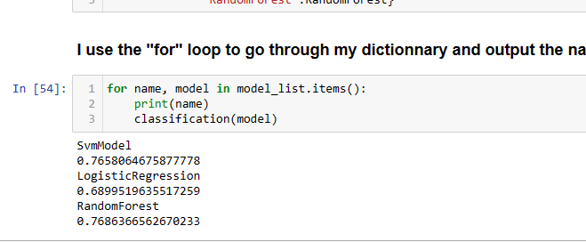

After some hyper parameter tuning, I obtained an accuracy of 85% with precision, recall, and f1-score in each class all above 80% as shown below.
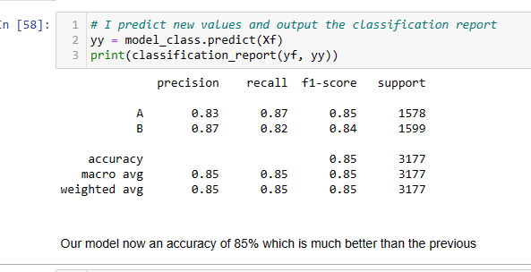

The deployed model perform as expected. Below are some screen shot of the deployed environment


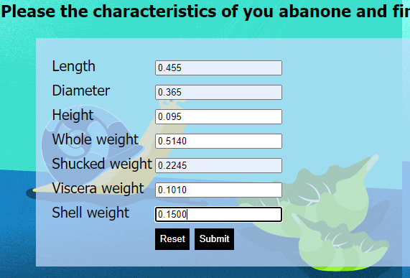

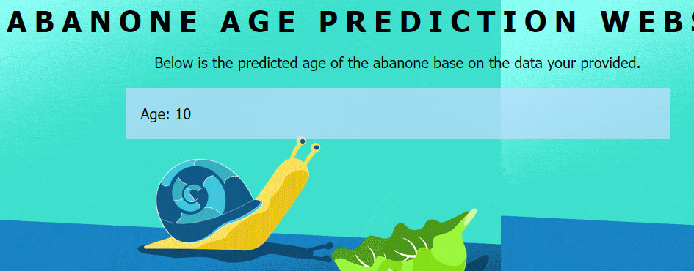

- Conclusion:
- Conclusion
This project could be approached in various way. Classification or regre sion, depending on the objectives. I used the two approaches and decided to deploy the regression model, as I wanted a number to be display to refer the age and not a range. However, the classification model show a better performance with an accuracy of 84%, which is good for a classification problem. A next step would me adding another button that will output the age base on the class/category, on our page, to let the user decide which format best suit him/her.

